**VPC – Virtual Private Cloud**

Ability for customer to create private network space on top of amazon network

Launched in Dec-2013. Before that instances are secured with security group

EC2 Classic – EC2 instance running out of VPC

VPC is within a region. It cannot be between regions

VPC is with a region between multiple Availability Zones

Tenancy applies for VPC. If selected to be in a dedicated host, VPC will be created in a dedicated host

VPCs are not global network. They are regional network that span in multiple availability zones

VPC comes with internal DNS Option. We can ignore it and create our own DNS Server and have our own name for the Instances

Web Browser 🡪 Open Internet 🡪 Internet Gateway 🡪 VPC

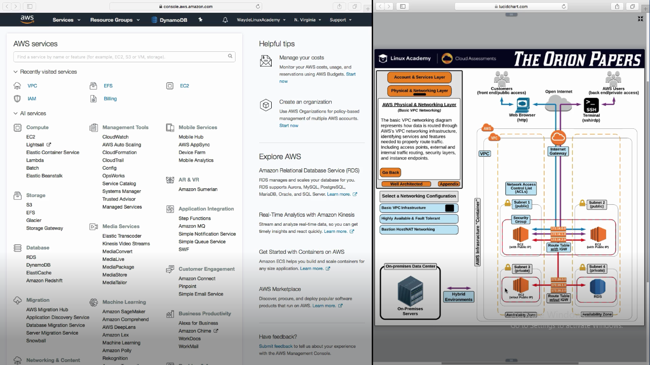

**Internet gateway** helps in communication from outside internet to VPC

It is one to one mapping with VPC

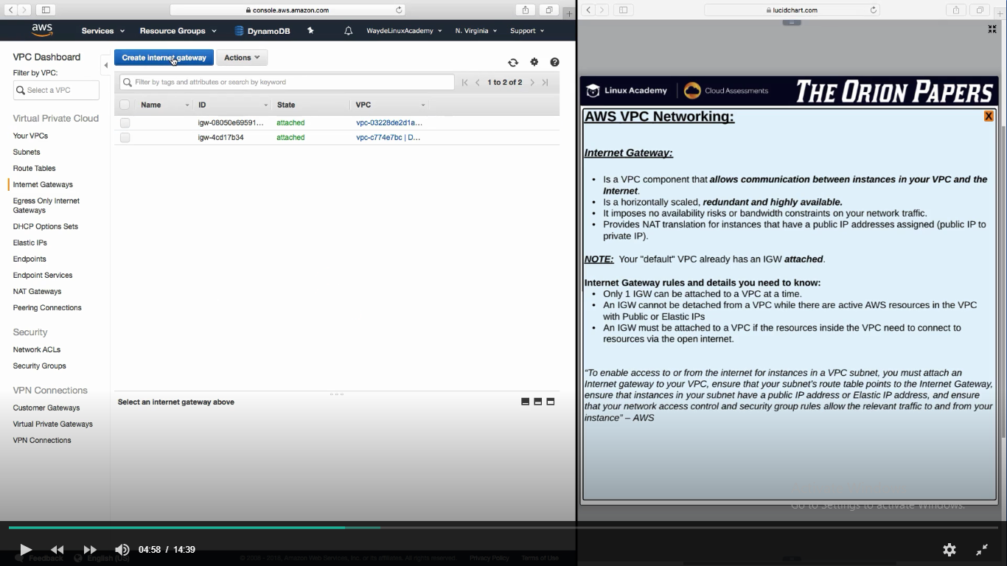

**VPC have Virtual Private Gateway**

Attach the virtual private gateway to your VPC. You can make a hardware based VPN connection from your data center straight to our VPC. This allows extending your corporate network into AWS like its one single network. This is a hybrid environment.

**What is CIDR**

Classless Inter Domain routing

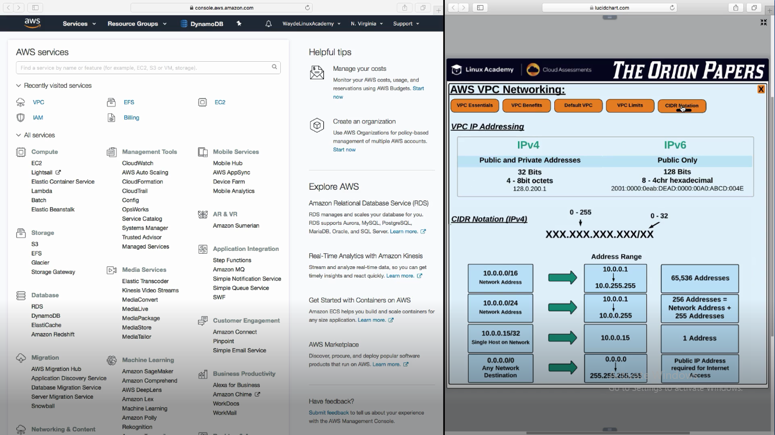

IP Ranges from: 0.0.0.0 to 255.255.255.255

**Benefits of VPC**

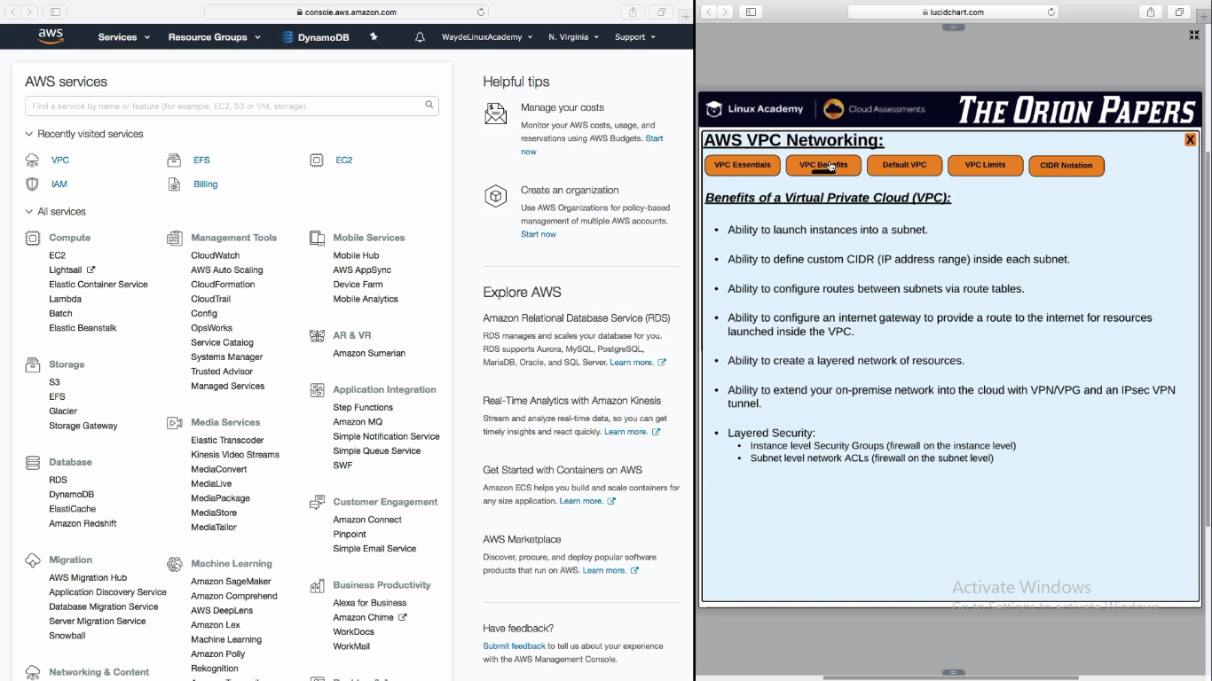

**Default VPC**

All these limits are soft. We have to contact AWS support to increase it

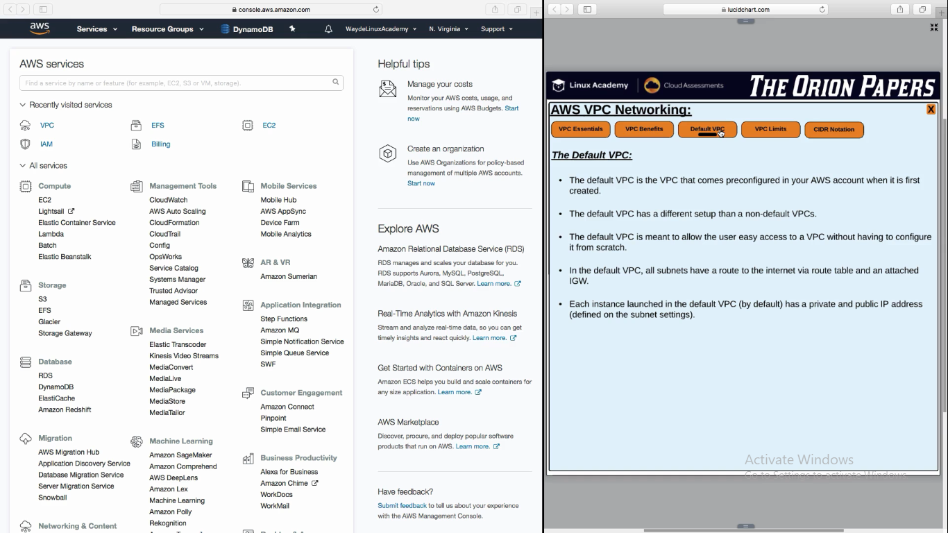

**Subnet Creation**

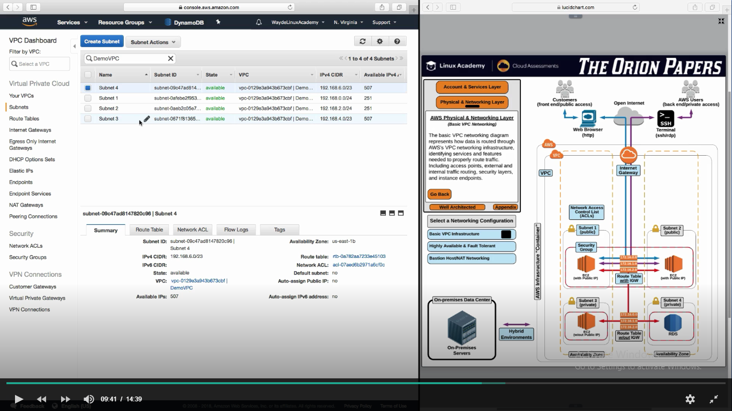

**Route Table**

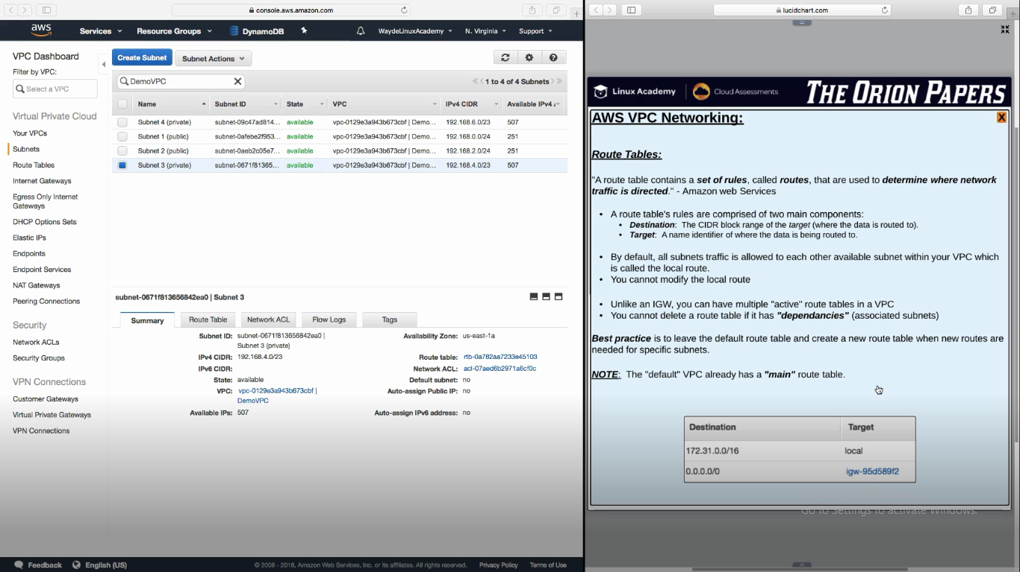

Create a Route Table and associate it to VPC

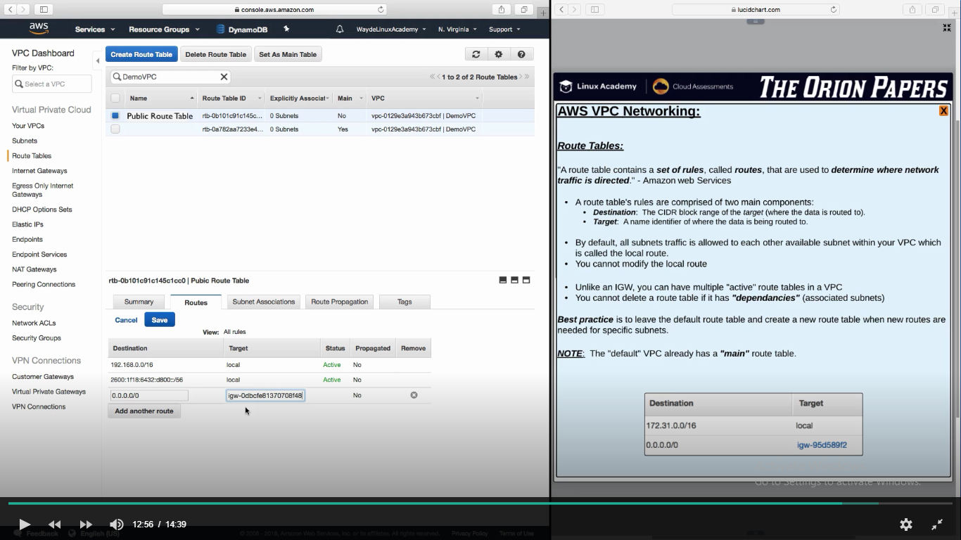

Route Table 🡪 Set routes destination and target. Target is the internet Gateway

Route Table 🡪 Map the subnets

**Security Level in VPC**

NACL is two way because they are stateless – inbound and outbound

We can add allow and deny rules in NACL

NACL is associated with Subnets

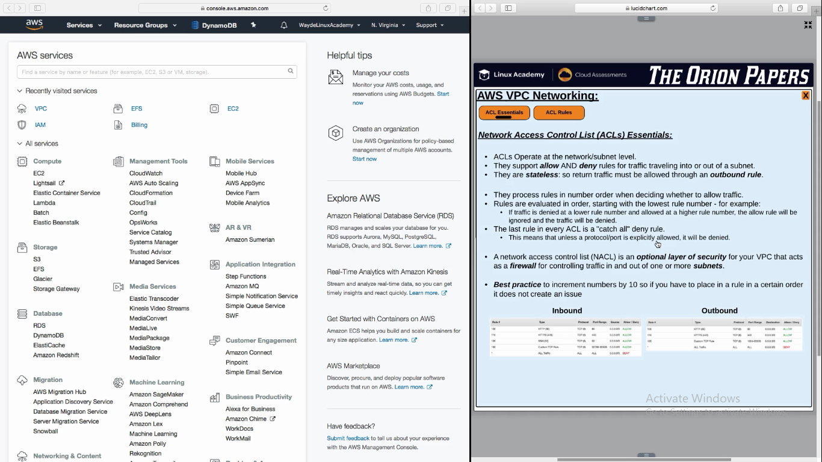

**NACL Configurations**

We will set both inbound and outbound rules

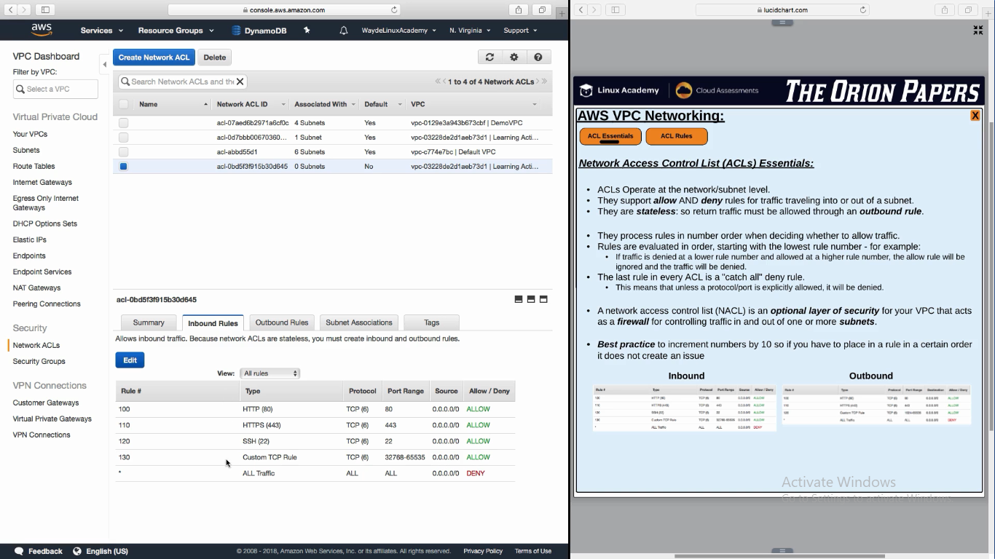

**NACL Associated to subnets**

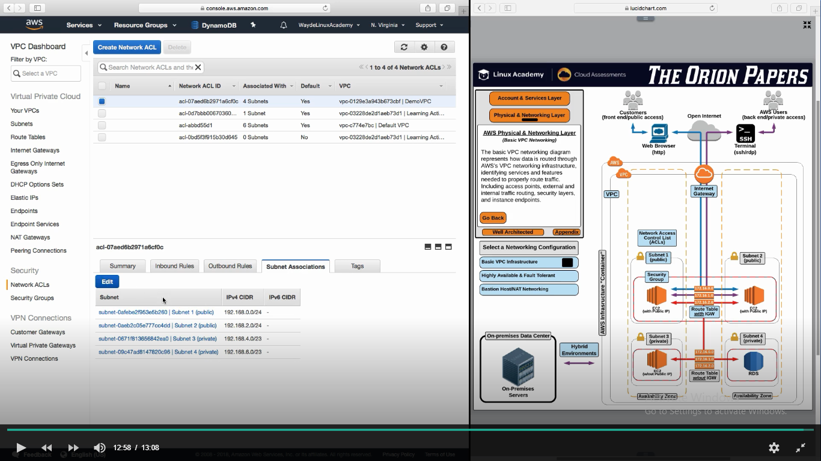

**Control comes from NACL to SG**

We will set only in bound rules for SG. Because they are stateful

SG is associated to instances

